Cell Model
Aim: to model a plant and animal cell showing the major components of each.

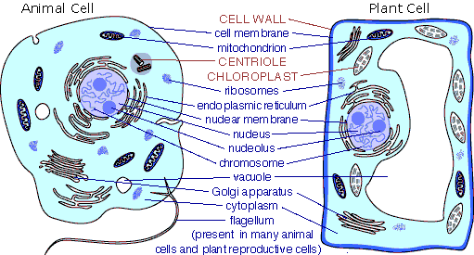

Equipment supplied:
Milk Arrowroot biscuits (pre-iced pink)
Nice biscuits (pre-iced green)
Packets of the following lollies:
Allen’s strawberries and cream
Allen’s jelly beans (small)
Cosmic-Karate Belts (pre-cut)
Natural Food Confectionery Co. party mix
Boiled hard lollies
Hundreds and thousands (small amount in vials)

Method: Do in pairs. Each pair to make a plant and animal cell.

